Assignment Cover Sheet

Qualification |  | Module Number and Title
Higher Diploma in Computing and Software Engineering |  | CSE5013 Service Oriented Computing
Student Name & No. |  | Assessor
Ometh Bandara  KD/HDCSE/CMU/77/42 |  | Mr. Gihan Herath
Hand out date |  | Submission Date
Assessment type  Course work | Duration/Length of  Assessment Type  3000 words | Weighting of Assessment  100%

Learner declaration
I, R.A.W.G.O.N.S.Bandara KD/HDCSE/CMU/77/42………………………………………….<name of the student and registration number>,
certify that the work submitted for this assignment is my own and research sources are fully acknowledged.

Marks Awarded
First assessor
IV marks

Agreed grade
Signature of the assessor |  | Date

FEEDBACK FORM INTERNATIONAL COLLEGE OF BUSINESS & TECHNOLOGY

Module: Service Oriented Computing-CSE5013
Student: R.A.W.G.O.N.S.Bandara
Assessor: Mr. Gihan Herath
Assignment:

Strong features of your work:

Areas for improvement:

Marks Awarded:

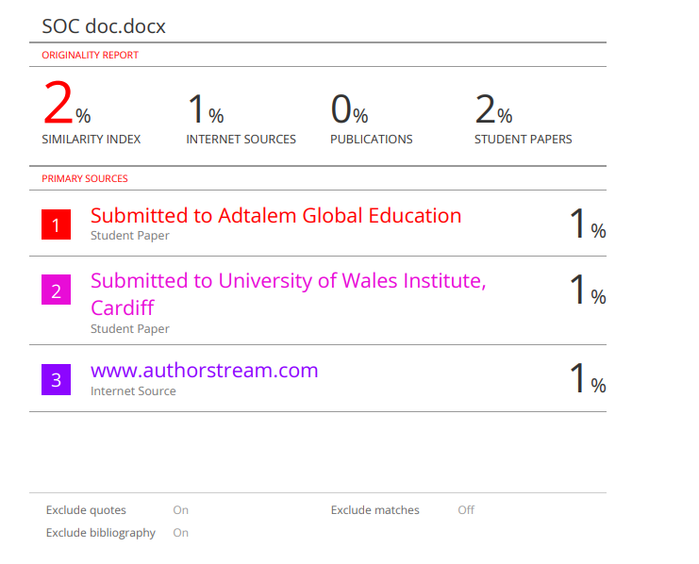

Acknowledgment

- I would like to express my sincere gratitude to my lecturer, Mr. Gihan Herath, for her continuous guidance and support throughout this assignment. I also extend my appreciation to my classmates for their constructive feedback and collaboration.

- Additionally, I acknowledge the resources and facilities provided by ICBT Campus, which greatly assisted in completing this project. Finally, I thank my family and friends for their encouragement and support during the development of this web application

Contents
Acknowledgment 5
Task 01 7
How both architecture models can be used for the KMC case study 7
Comparison: 8
Justification: 10
Task 02 10
Diagrams 11
Use Case Diagram: 11
Sequence Diagram: 12
Class Diagram: 13
Architecture Diagram: 14
Login.cshtml: 15
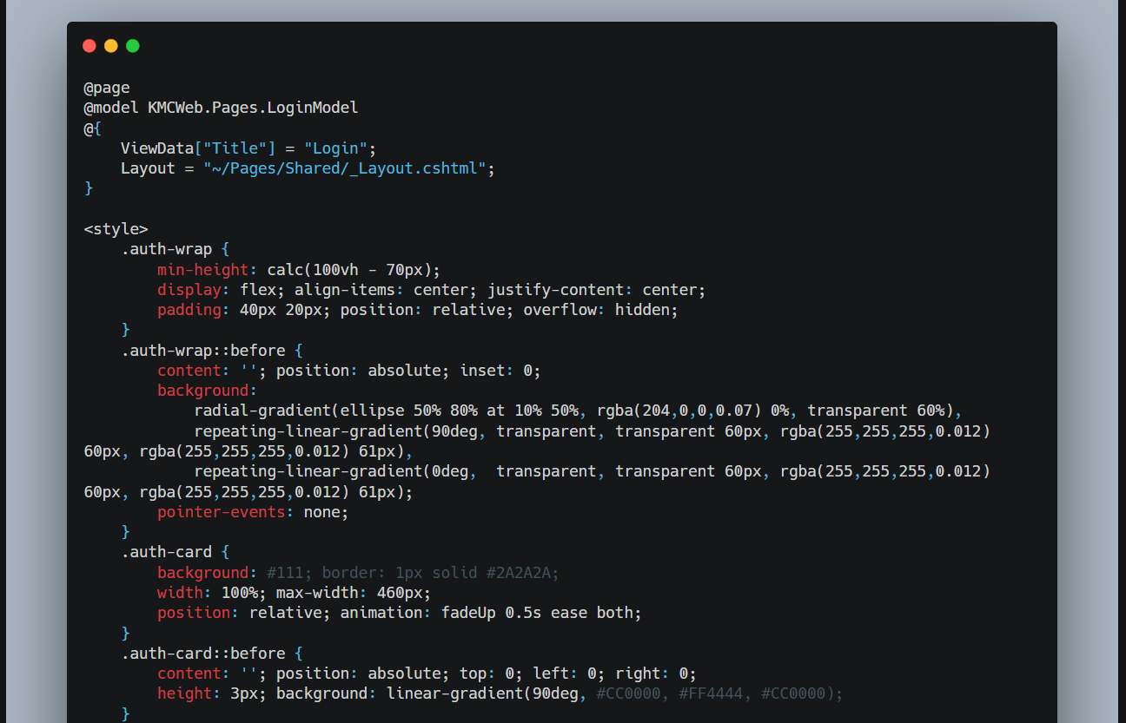 15
Code Explanation: 18
Register.cshtml: 18
Code Explanation: 22
Task 03 23
Test Cases: 23
Task 04 29
Traditional Server Deployment: 29
Advantages 29
Disadvantages 30
Docker Containerisation: 30
Advantages 31
Disadvantages 32
Kubernetes Orchestration: 32
Advantages 33
Disadvantages 33
Justification: 34

Task 01

How both architecture models can be used for the KMC case study

- The Event Management Platform developed for the Kandy Municipal Council (KMC) needs a strong and reliable system design to handle multiple functions such as creating and managing events, registering participants, allowing the public to search for events, and providing API access for external organizers. There are two main ways this system can be built: using a Monolithic architecture or a Service-Oriented Architecture (SOA), and each approach has its own advantages. (Newman, 2015) In a Monolithic setup, the entire KMC platform would be built as a single .NET application. This means all parts of the system including event management, participant registration, search features, the organizer dashboard, and even the public website would exist within one codebase and share the same database. Everything is tightly connected, making it simpler to develop and deploy as one unit. This approach works well when the system is still small and not overly complex. (Richard, 2015) For example, if KMC is only handling a limited number of city events in the early stages, a monolithic structure allows the team to build and launch the platform quickly without dealing with the complications of managing multiple services. It’s especially suitable when there’s a single development team and the focus is on speed and simplicity rather than scalability.

- In contrast, a Service-Oriented Architecture (SOA) breaks the same platform into smaller, independent services. (Erl, 2007) Each service focuses on a specific function, such as event management, user registration, or search, and they communicate with each other through clearly defined APIs. (Josuttis, 2007) Instead of one large system, the platform becomes a collection of smaller parts that work together. SOA is based on the idea of building software as a set of reusable and loosely connected services. These services can be developed, updated, and deployed separately without affecting the entire system. This makes the platform more flexible, as different parts can evolve over time or even be reused in other applications when needed.

- In this setup, the KMC website acts as just one of many clients that use the platform’s API. Since the API can be accessed from any technology, the website itself can be built using any framework while still connecting to the same backend services. (P.Papazoglou, 2007) At the same time, external event organizers can link their own systems directly to the platform through a shared API gateway. This removes the need for manual data entry and allows them to publish and manage events more efficiently without needing direct access to the internal system. This API-driven approach is a key strength of SOA, especially in situations where multiple independent users or organizations need to work within the same ecosystem. It allows different parties to interact with the platform in a controlled and consistent way, which fits well with KMC’s requirement to support third-party integrations.

Comparison:

Aspect | Monolithic | SOA | Criteria
Deployment | Entire system must be redeployed for any change a bug fix in registration redeploys the whole KMC platform. | Each service deploys independently the Registration Service updates without touching Event Management or Search. | Independent deployability components should be releasable individually to reduce risk and enable faster release cycles.
Scalability | Only the whole application scales (vertical). During peak event days, every module scales even if only search is under load. | Only the Search Service scales horizontally during peak traffic other services remain untouched, reducing infrastructure cost. | Horizontal scalability high-demand components must scale independently without requiring the entire system to scale.
Maintainability | Tightly coupled code changing event logic risks breaking registration or search. Complexity increases with every new feature. | Each service has a single responsibility. Changes to one service carry no risk to others safer and faster to maintain over time. | Modular maintainability a change in one area must not risk breaking unrelated parts of the system.
Fault isolation | A crash in the Registration module takes down the entire KMC platform, including the public event listing. | A failed Registration Service does not affect Search or Event Display the platform stays partially available. | Resilience a failure in one component must not cascade across the whole system.
Third-party integration | External organizers connect to the full monolith creating security risks and tight coupling with internal code. | External organizers use scoped API endpoints only internal service logic is never exposed to third parties. | Secure integration third parties must interact through a controlled API surface without access to internal implementation.
Technology | Single stack throughout. Upgrading one library carries risk across all features simultaneously. | Each service chooses its own stack. The brief allows any platform for the client only possible with SOA's decoupled design. | Technology flexibility different parts of the system should adopt the most suitable technology independently.
Extensibility | Adding Ticketing or Notifications requires modifying the existing codebase regression risk grows with every addition. | New services are added alongside existing ones with zero changes to what already works the platform grows without debt. | Extensibility new capabilities must be addable without modifying stable, existing components.

Justification:

- Based on the comparison above, SOA is the more suitable choice for the KMC Event Management Platform because it handles both maintainability and scalability much better. Since the system is divided into smaller, independent services, developers can update or fix one part without affecting the rest of the platform. This reduces the risk of breaking the entire system and makes ongoing maintenance easier. It also performs better when the system grows. Instead of scaling the whole application, only the services that are under heavy demand need to be scaled, which is more efficient and cost-effective. On the other hand, a monolithic approach may seem easier at the beginning, but it quickly becomes difficult to manage as the platform expands. Even small changes can impact the entire system, scaling becomes more expensive, and integrating third-party services becomes more complicated because everything is tightly connected (Erl, 2007).

Task 02

Diagrams

Use Case Diagram:
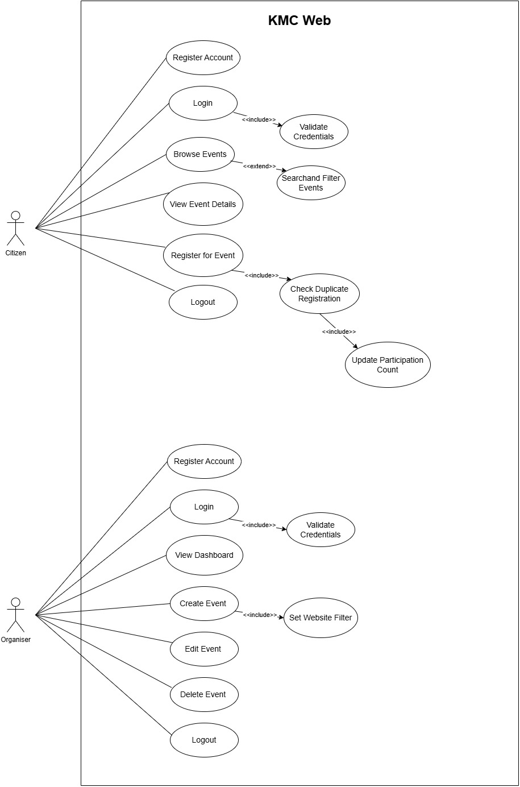

Sequence Diagram:
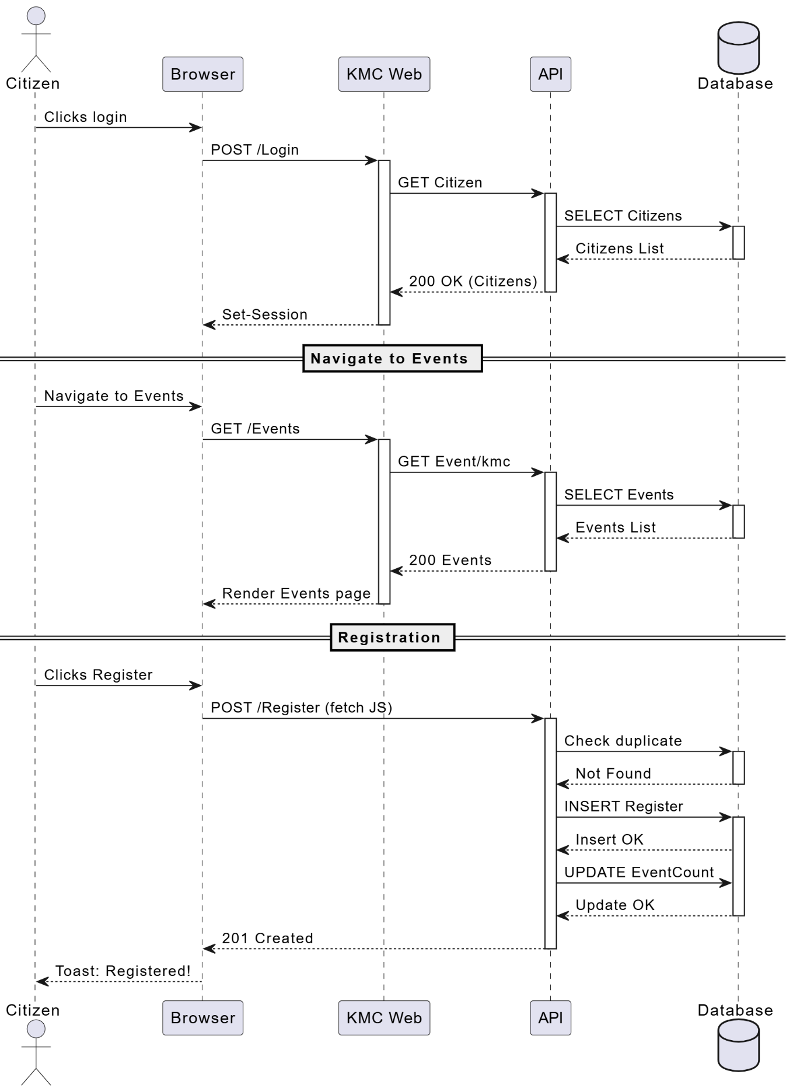

Class Diagram:
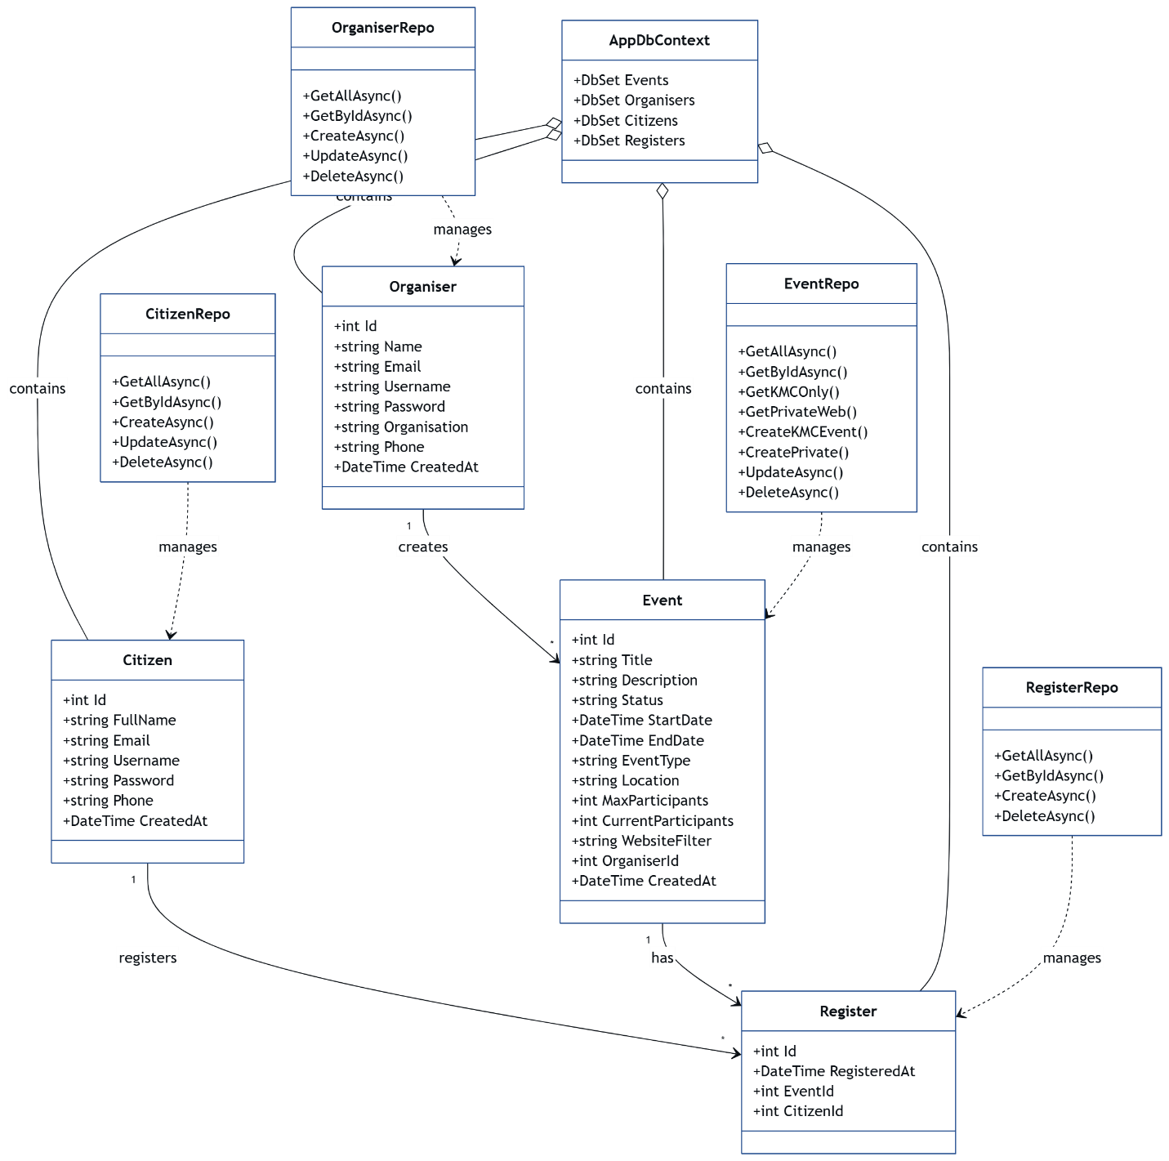

Architecture Diagram:
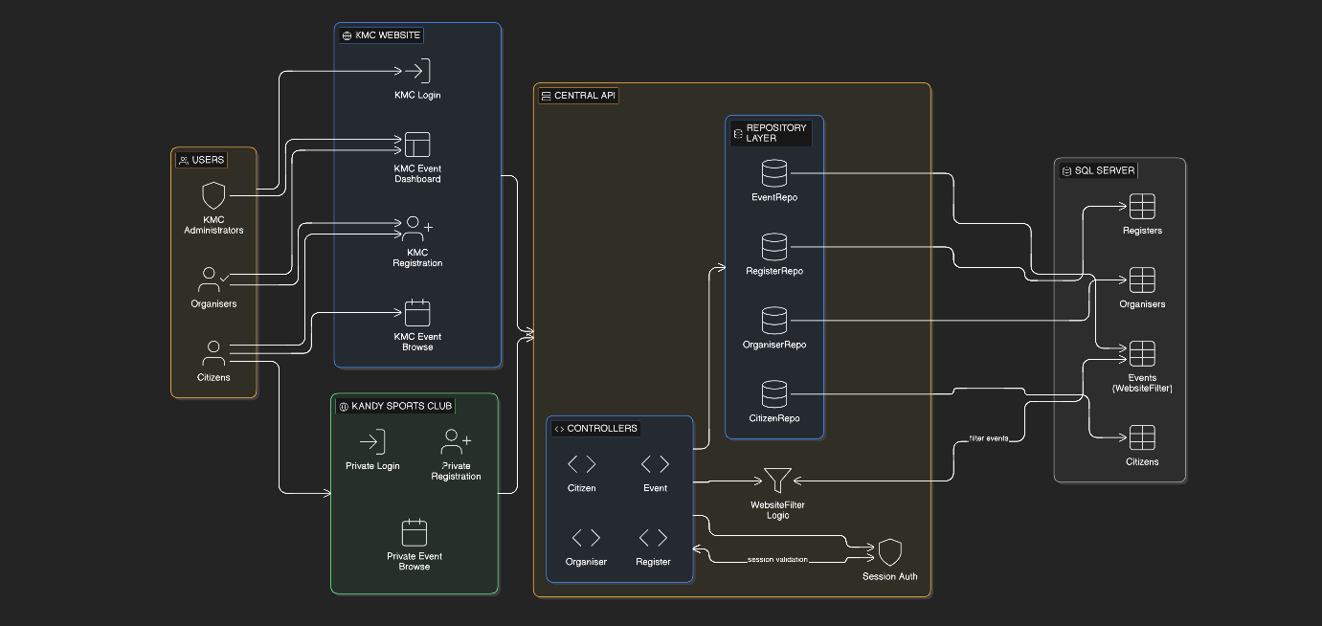

s

Login.cshtml:



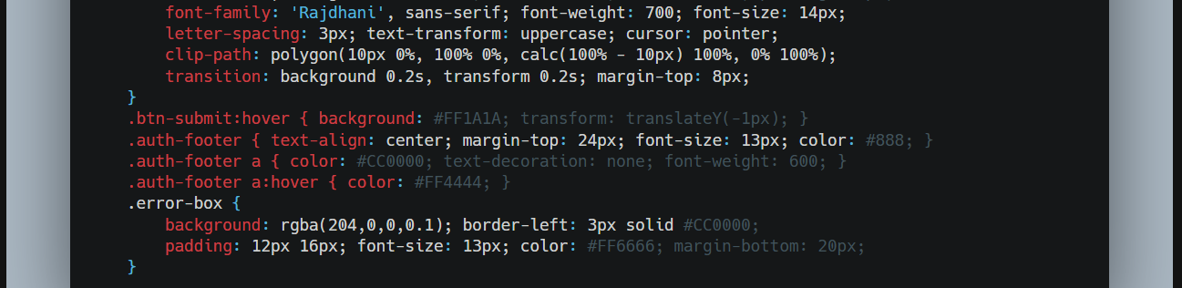
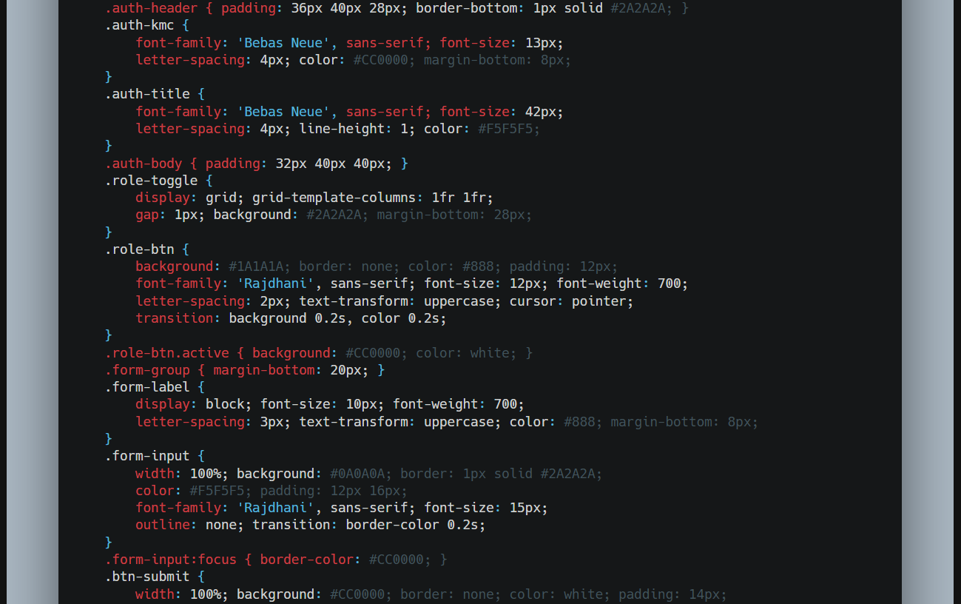

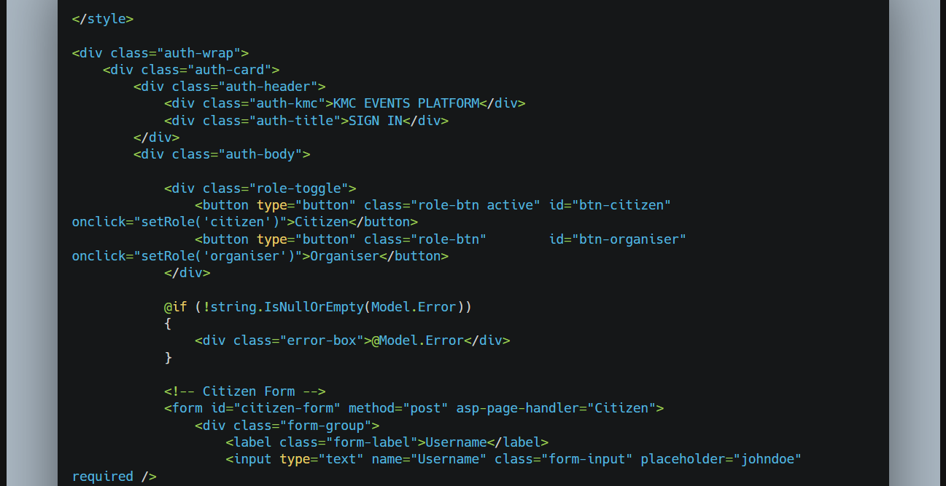
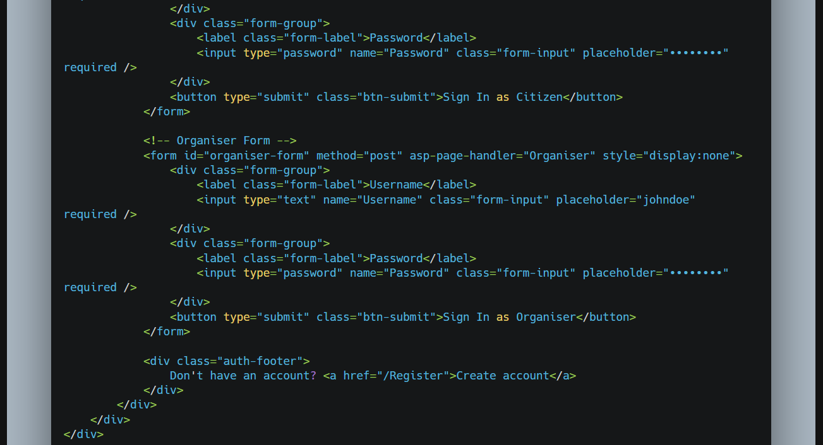

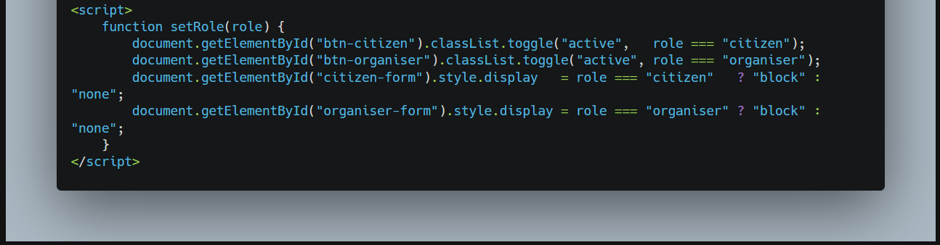

Code Explanation:

- This KMC website login page is a modern, dark-themed interface designed for both Citizens and Organizers. The page centers around a stylish login card with a subtle textured background, featuring faint red glows and grid patterns for depth. At the top, the card displays the site branding, “KMC EVENTS PLATFORM,” and a bold “SIGN IN” title to make it clear where users are. Users can toggle between Citizen and Organizer roles using two buttons at the top of the card. When a role is selected, it turns red, and the corresponding login form is shown while the other is hidden. This dynamic switching is handled by a small JavaScript function (setRole) that adjusts the active state of the buttons and shows or hides the appropriate form. Each form has fields for Username and Password, styled with a clean dark background and subtle border highlights. When users click into a field, the border turns red to indicate focus. There’s a prominent red submit button with a slanted corner design, which lifts slightly and changes shade on hover, adding interactive feedback. If login fails, an error message appears in a red alert box for immediate visibility. Finally, the card footer provides a helpful link for new users to create an account, keeping navigation simple and user-friendly. Altogether, this page combines aesthetic design, responsive role selection, and clear visual feedback to create a polished, professional login experience for multiple types of users.

Register.cshtml:

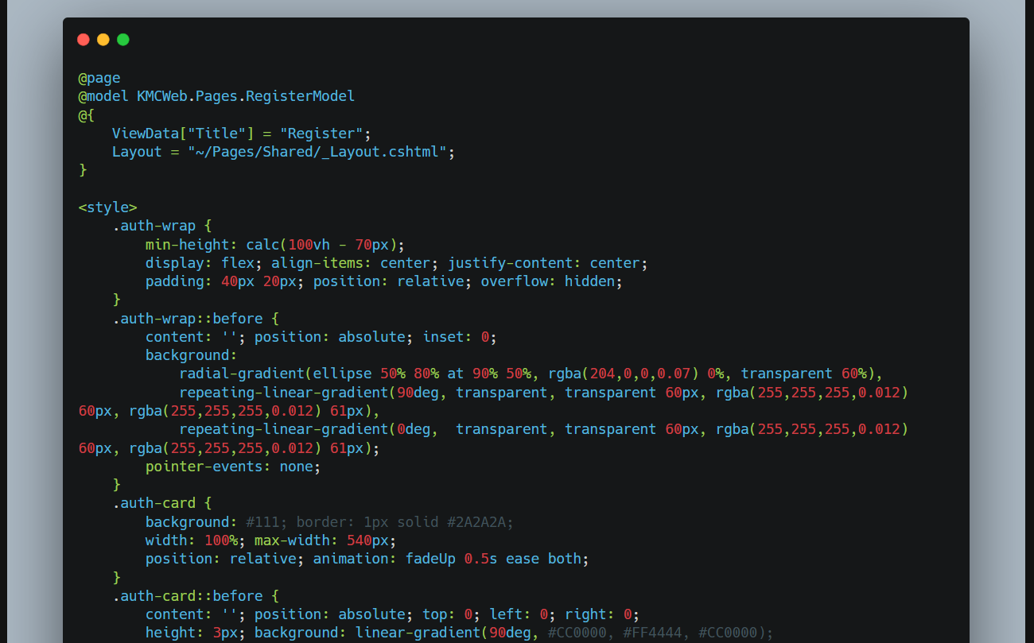

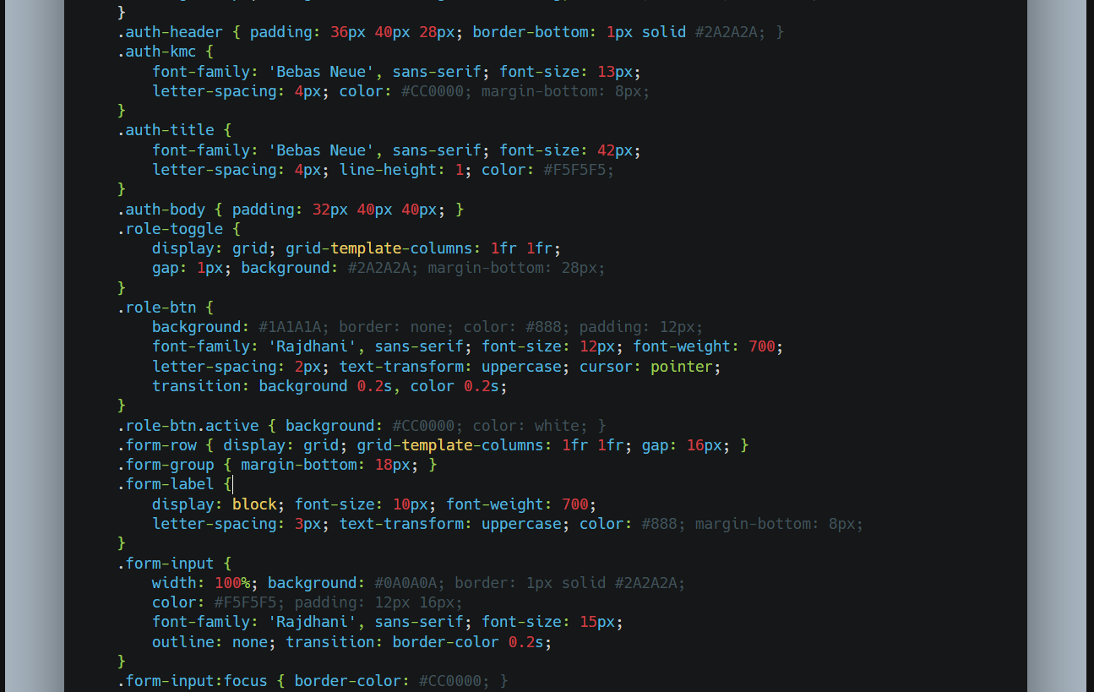
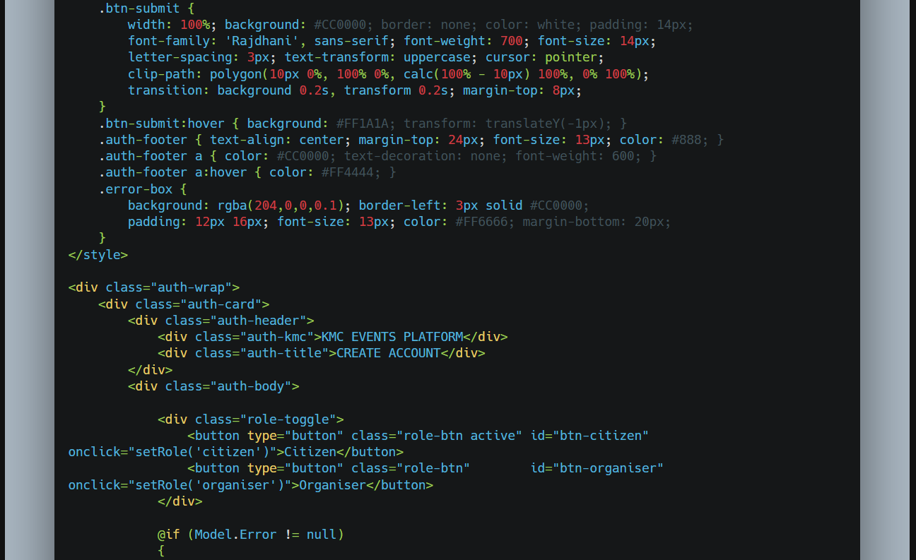

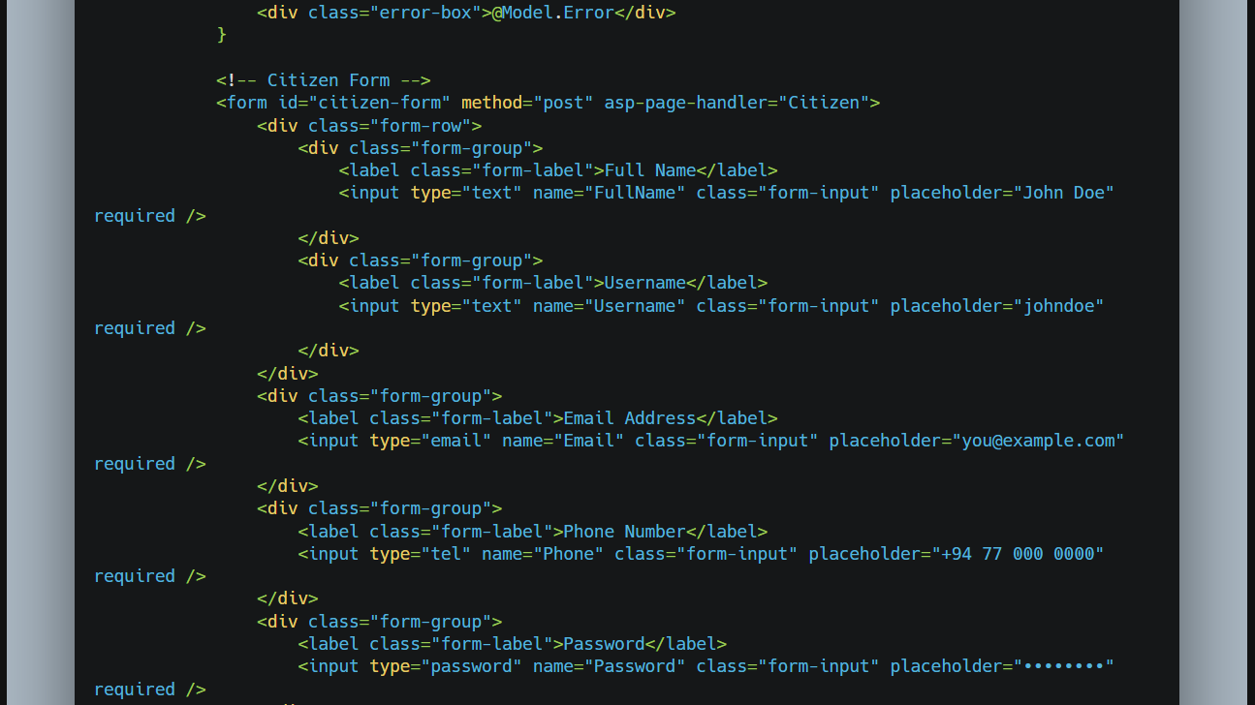

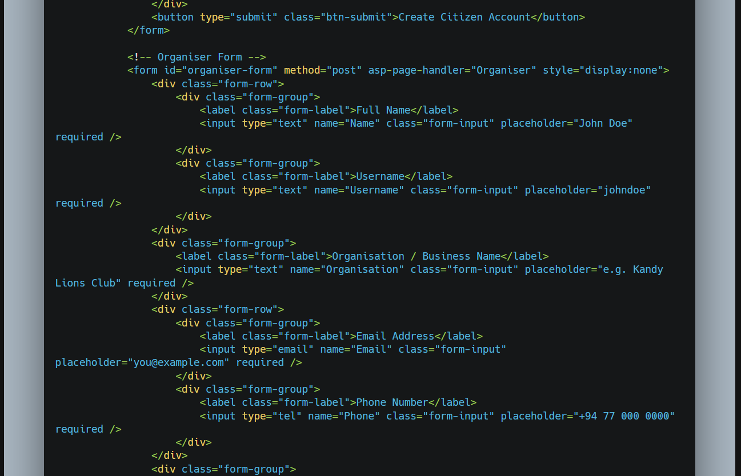

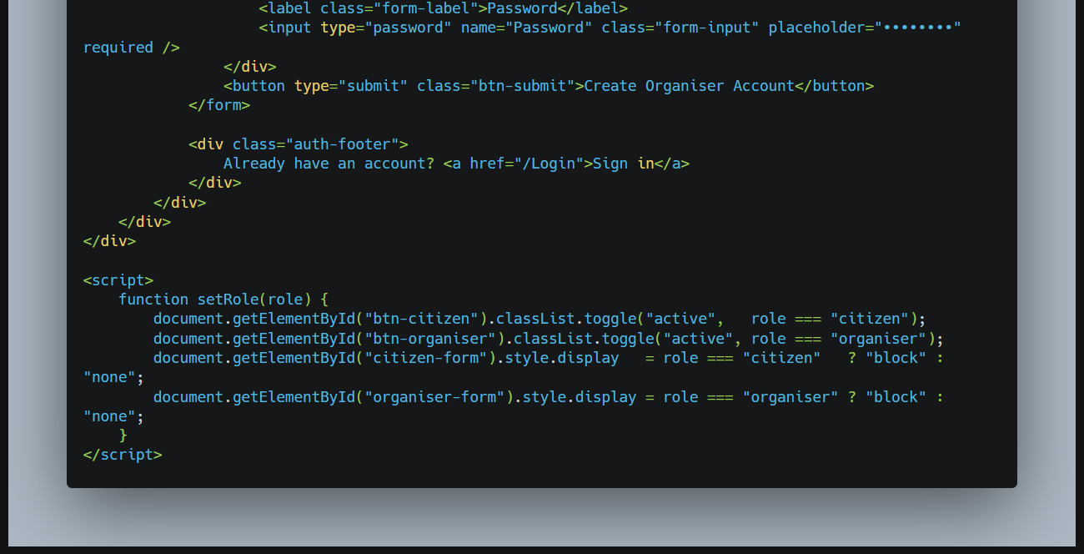

Code Explanation:

- The KMC website Register page is a sleek, dark-themed registration interface designed for both Citizens and Organizers, keeping a modern, user-friendly look consistent with the login page. At the center is a stylish card with subtle red glows and faint grid patterns in the background, creating a professional and visually appealing feel. The card header displays the site branding, “KMC EVENTS PLATFORM,” along with a bold “CREATE ACCOUNT” title. Users can switch between Citizen and Organizer registration using two toggle buttons. The active role is highlighted in red, and the corresponding form is displayed while hiding the other, thanks to a small JavaScript function (setRole) that handles dynamic visibility. The Citizen form collects essential information: full name, username, email, phone number, and password, while the Organizer form gathers similar personal details along with the organization or business name. The forms use neatly styled input fields with a dark background and red focus highlights, keeping a clean and modern look. Each form has a bold, slanted red submit button with a hover effect that slightly lifts the button and brightens its color, giving interactive feedback. If an error occurs during registration, a clear red alert box displays the message for immediate attention. Finally, the footer guides users who already have an account to the login page, ensuring smooth navigation. Overall, this page combines modern design, role-specific dynamic forms, clear input feedback, and easy navigation, creating a polished and professional registration experience for multiple types of users.

Task 03

Test Cases:

T1 | Citizen Created | 200 Created | 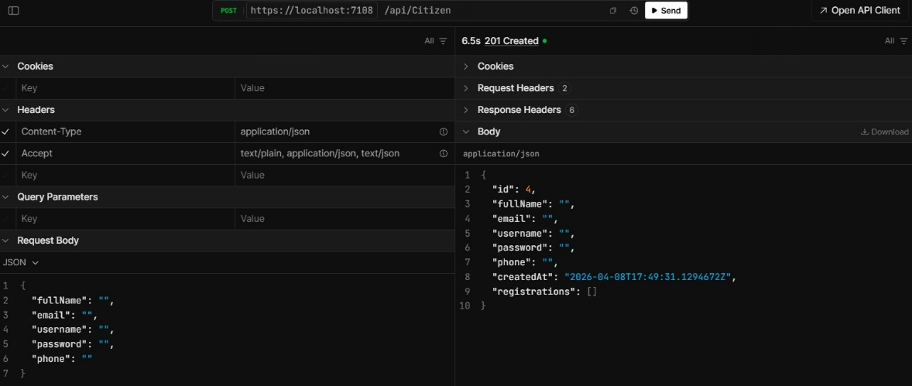 | PASS
T2 | Get Citizen | 201 OK | 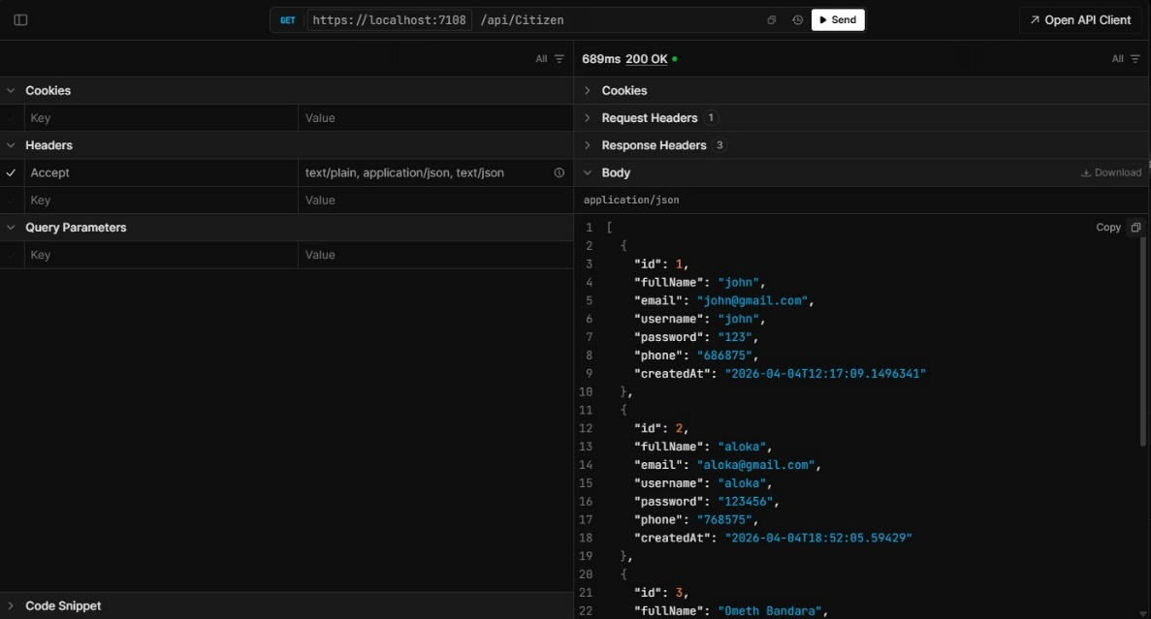 | PASS
T3 | Event Created | 201 Created | 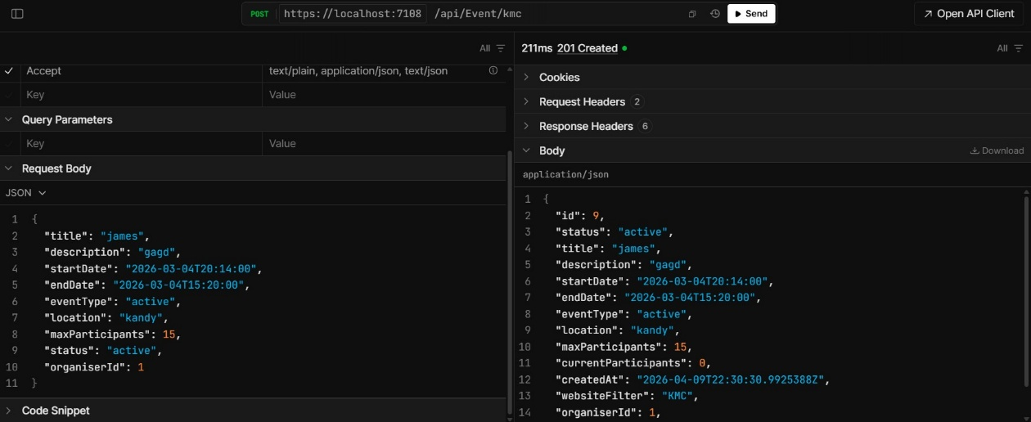 | PASS
T4 | Get Event | 201 Ok | 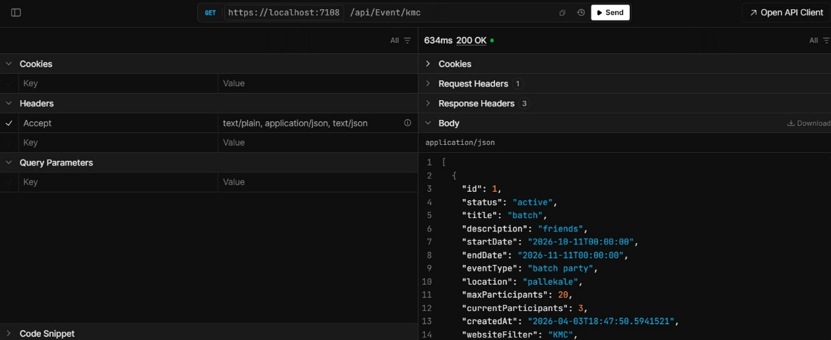 | PASS

T5 | Private Web Event Created | 201 Created | 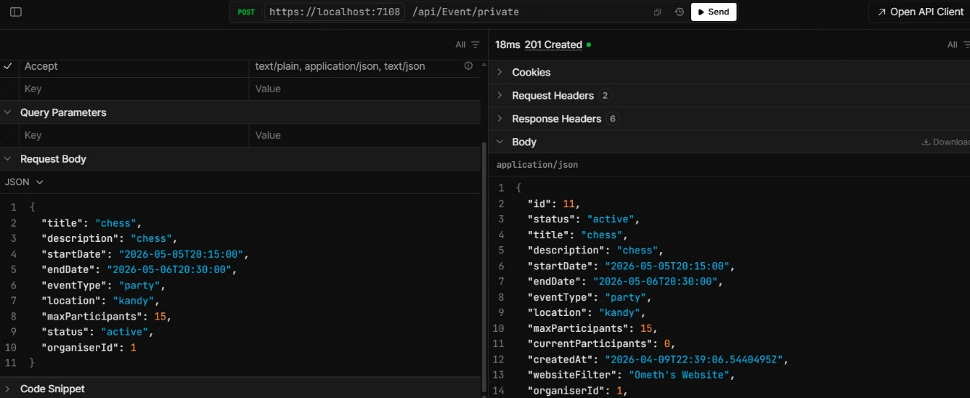 | PASS
T6 | Private Web Get Event | 200 OK | 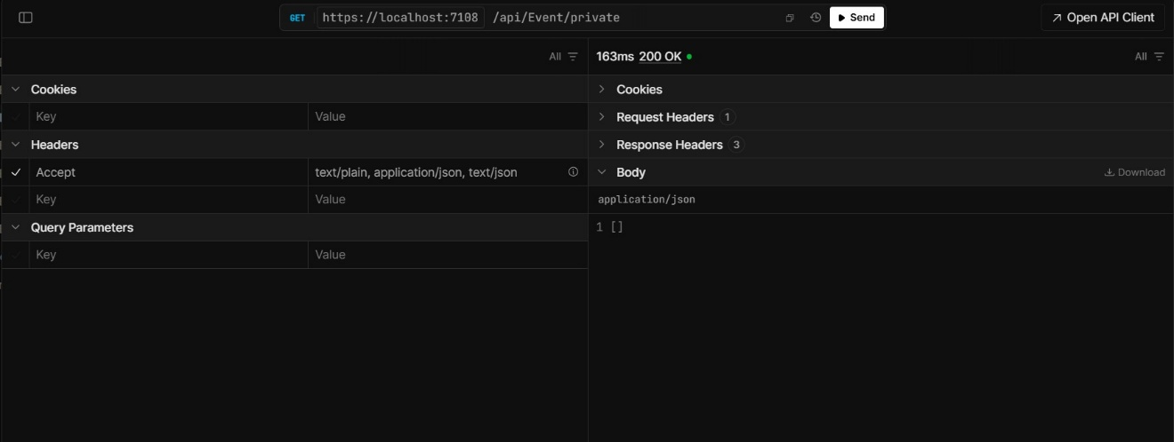 | PASS

T7 | Organizer Created | 201 Created | 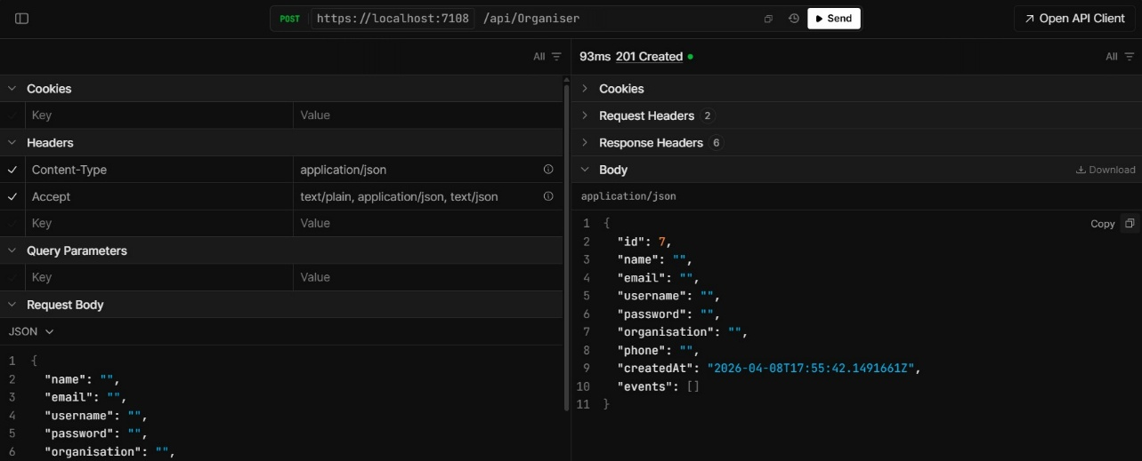 | PASS
T8 | Get Organizer | 201 Ok | 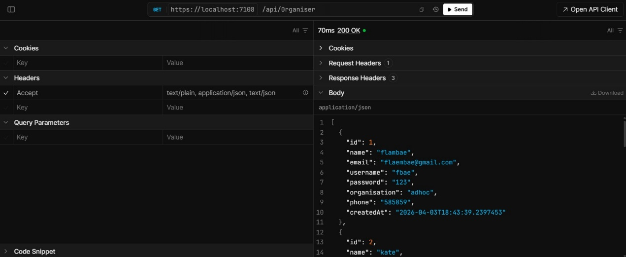 | PASS

T9 | Event Registered | Successfully registered for event! |  | PASS
T10 | Organizer event deleted | Event deleted | 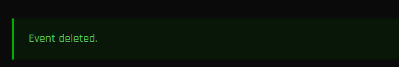 | PASS

T11 | Organizer event updated | Event updated successfully! | 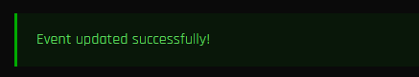 | PASS
T12 | Organizer event created | Event created successfully! | 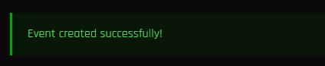 | PASS

Debugging Process:

- Screenshot 1: API Test Result – 404 Not Found
This screenshot displays a DELETE request to https://localhost:7108/api/Citizen/{id} with id=1. The API responded with 404 Not Found status.
The response body contains standard Problem Details JSON showing:
- Title: "Not Found"
- Status: 404
- TraceId for debugging
Explanation: The requested Citizen resource with ID 1 does not exist in the database or the route is not correctly mapped. No request body was sent. This is a common error when the resource is missing.
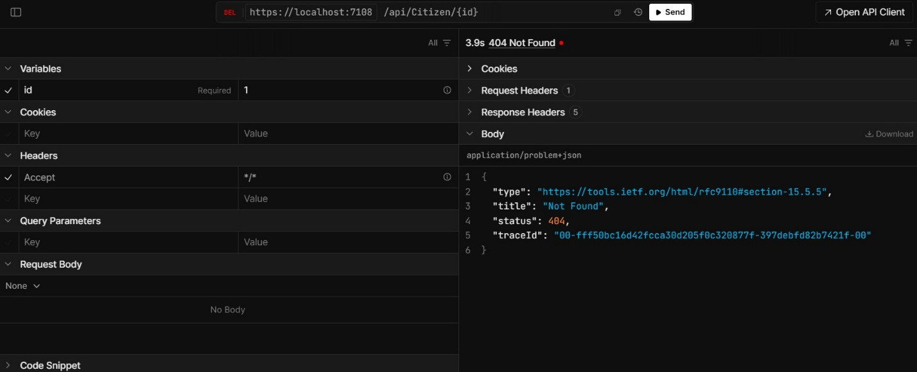

- Screenshot 2: Debugger in OrganiserController.cs (Delete Method)
This screenshot shows the Visual Studio debugger paused at line 88 inside the Delete(int id) method of OrganiserController.cs.
The code executed is: var success = await _repo.DeleteAsync(id);
The debugger is currently highlighting this line with id = 2. The yellow arrow indicates the next line to execute.
Explanation: The application is debugging the DELETE endpoint for an Organizer. It calls the repository to delete the record and checks the result to return either NotFound or NoContent.
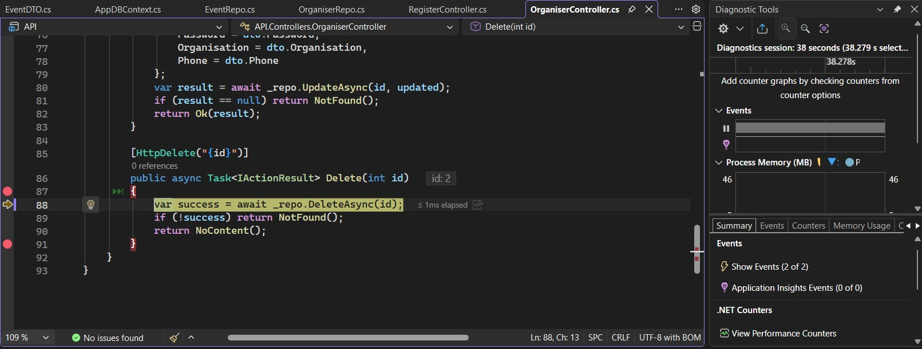

- Screenshot 3: Debugger in OrganiserRepo.cs (DeleteAsync Method)
This screenshot shows the Visual Studio debugger paused at line 44 inside the DeleteAsync(int id) method of OrganiserRepo.cs.
The code executed is: var organiser = await _context.Organisers.FindAsync(id);
The debugger is highlighting this line with id = 2.
Explanation: The repository is trying to find the Organizer record by ID before deletion. If the record is not found, it returns false; otherwise, it proceeds to remove and save changes.
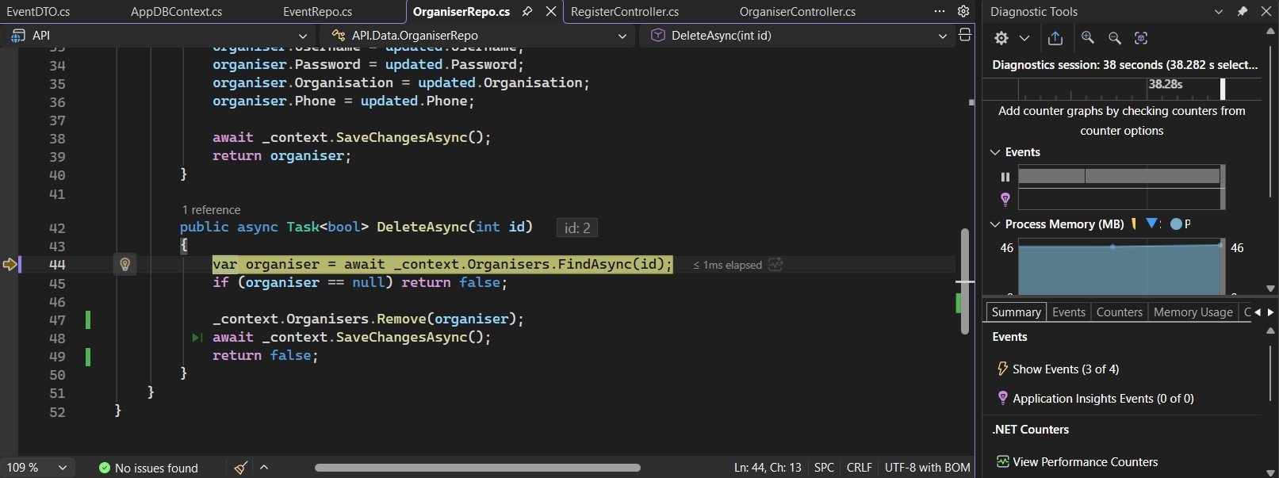

- Screenshot 4: Debugger in OrganiserRepo.cs (DeleteAsync Method)
This screenshot shows the Visual Studio debugger paused at line 45 with the condition: if (organiser == null) return false;
The debugger evaluated the condition as false (indicated by the arrow → false).
Explanation: The Organizer with ID 2 was successfully found in the database. The code will continue to the next lines to remove the record and save changes.
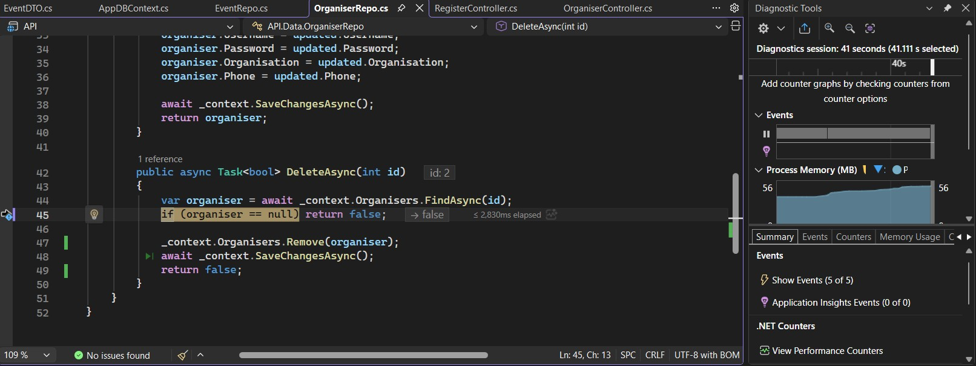

- Screenshot 5: Debugger in OrganiserRepo.cs (DeleteAsync Method)
This screenshot shows the Visual Studio debugger paused at line 47: _context.Organisers.Remove(organiser);
The yellow arrow indicates the next line to execute.
Explanation: The Organizer record with ID 2 was found successfully. The code is now removing the entity from the DbSet before calling SaveChangesAsync to delete it from the database.
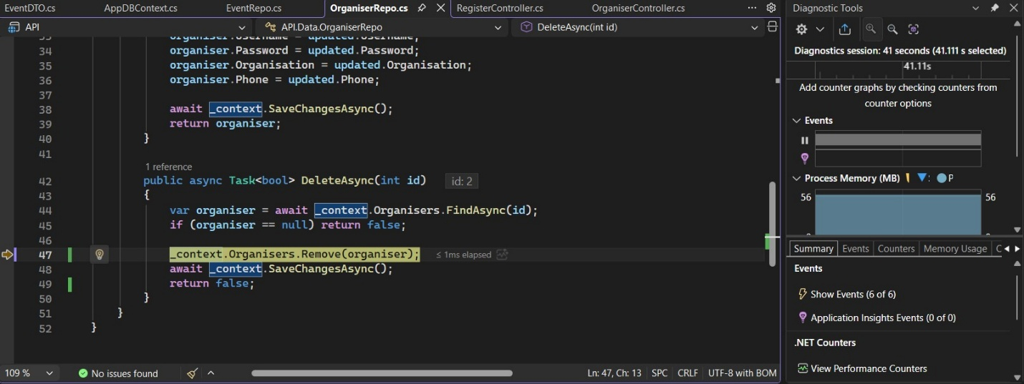

- Screenshot 6: Debugger in OrganiserRepo.cs (DeleteAsync Method)
This screenshot shows the Visual Studio debugger paused at line 48: await _context.SaveChangesAsync();
A tooltip displays: "Remove returned: {Organiser [Id: 2] Deleted}"
Explanation: The Organizer with ID 2 has been successfully removed from the context. The code is now saving the changes to the database to complete the deletion.
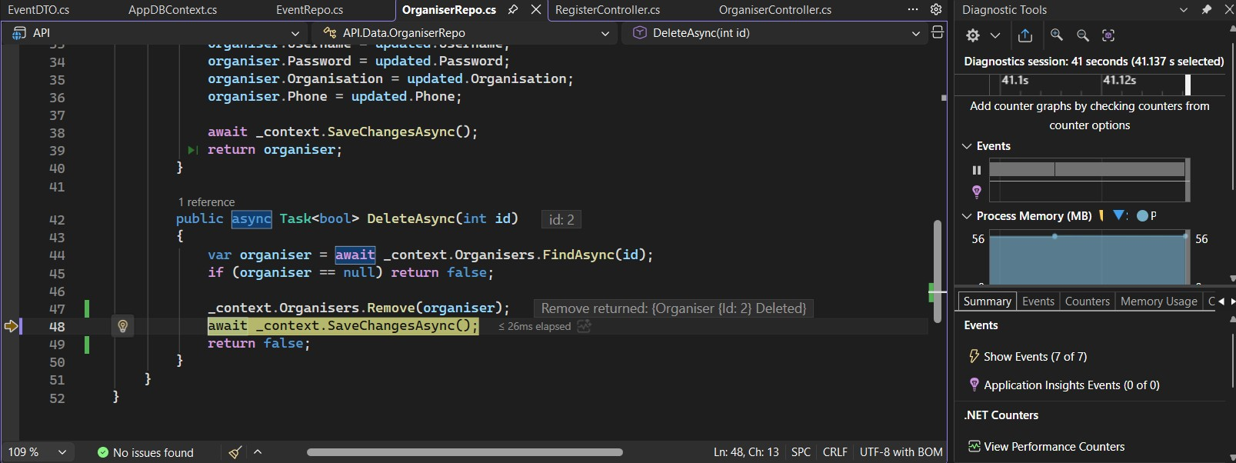

- Screenshot 7: Debugger in OrganiserRepo.cs (DeleteAsync Method)
This screenshot shows the Visual Studio debugger paused at line 49: return false;
The yellow arrow indicates the method is about to return false.
Explanation: After successfully removing the Organizer with ID 2 and saving changes to the database, the DeleteAsync method has completed and is returning false as per the current code logic.
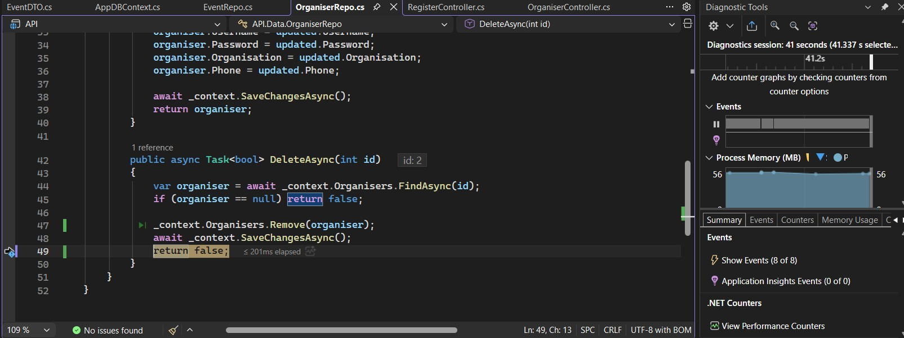

- Screenshot 8: Debugger in OrganiserRepo.cs (DeleteAsync Method)
This screenshot shows the Visual Studio debugger paused at line 50 (closing brace of the method) with the value ← false.
Explanation: The DeleteAsync method has finished executing and is returning false to the controller after successfully deleting the Organizer with ID 2.
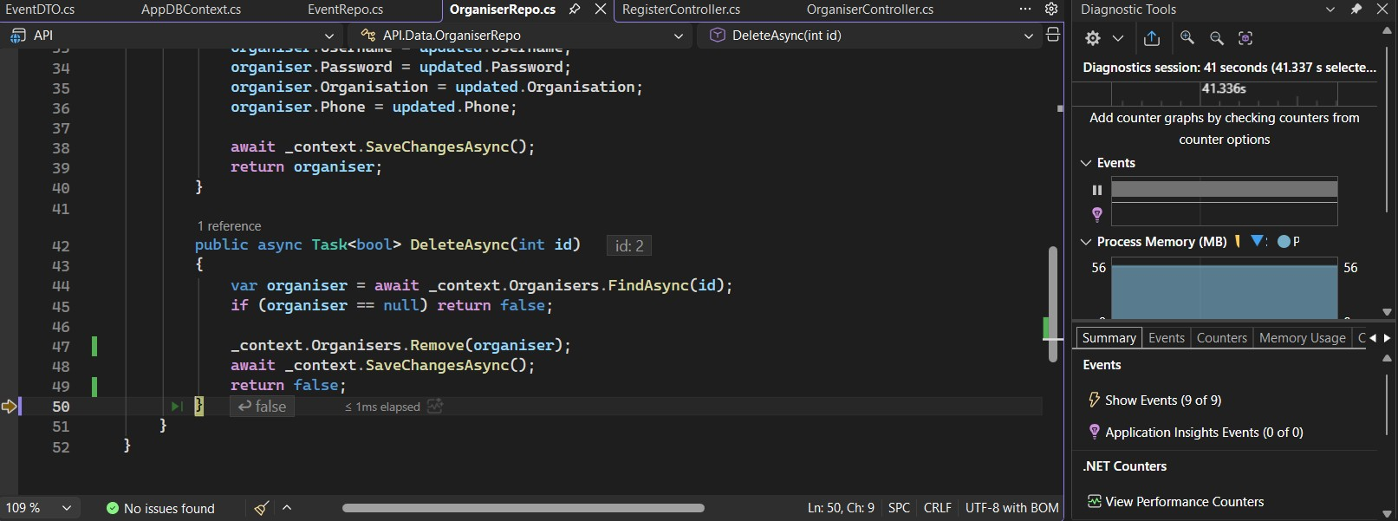

- Screenshot 9: Updated DeleteAsync Method in OrganiserRepo.cs
This screenshot shows the DeleteAsync(int id) method in OrganiserRepo.cs after modification.
The final line now returns return true; instead of false.
Explanation: The developer has fixed the return value so that the method correctly returns true upon successful deletion of the Organizer record. The debugger is currently paused before executing this return statement.
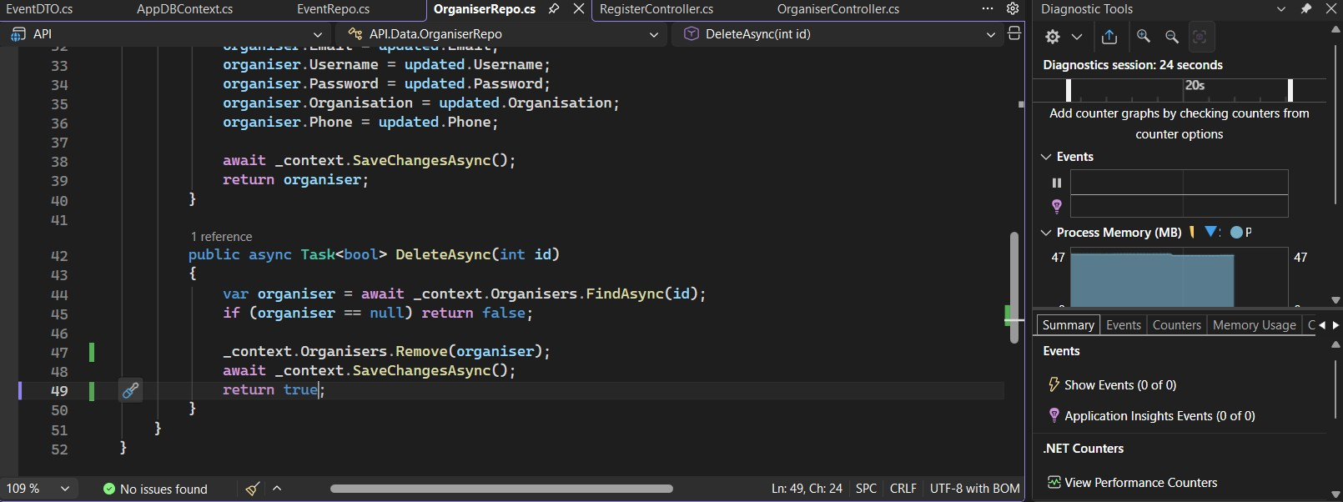

- Screenshot 10: Successful DELETE Request – 204 No Content
This screenshot shows a DELETE request to https://localhost:7108/api/Citizen/{id} with id = 3.
The API returned 204 No Content status with an empty body.
Explanation: The deletion was successful. The controller received true from the repository and returned NoContent as expected for a successful DELETE operation.
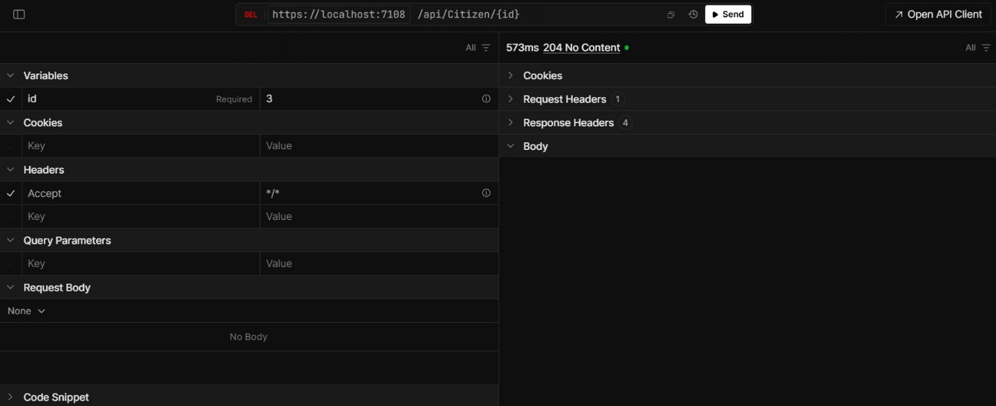

Task 04

Traditional Server Deployment:

- Traditional server deployment usually means running your application directly on physical hardware or virtual machines. In the case of the KMC platform, this would involve setting up a Windows or Linux virtual machine, installing the required .NET runtime along with SQL Server, and then deploying the API and both web applications separately. These components would run as individual processes, typically managed through Internet Information Services (IIS) or the built-in Kestrel web server that comes with ASP.NET Core.

Advantages

- One of the biggest benefits of this approach is how simple and familiar it is. Most municipal council IT teams are already comfortable working with Windows Server environments, so they wouldn’t need to learn more complex tools like Docker or Kubernetes. Setting everything up is fairly straightforward and doesn’t require knowledge of containerization or advanced networking concepts.

- Since the system is expected to run at a city level with relatively steady and predictable traffic, especially during the early stages, a properly configured virtual machine on a cloud platform like Microsoft Azure or AWS would be more than enough. Another advantage is the predictable cost you typically pay a fixed monthly amount for the virtual machine, regardless of how much traffic the system handles.

Disadvantages

- The main drawback of traditional server deployment, especially for a service-oriented system, is that it takes away some of the flexibility the architecture is supposed to provide. Service-oriented design is meant to allow each service to be deployed, updated, and scaled on its own. However, in a traditional setup, all components run within the same operating system and share the same runtime environment.

- This can create problems. For example, if one component needs a dependency update that isn’t compatible with another, it can end up affecting both. Scaling is also not very flexible if there’s a spike in demand, such as during a major city event, you can’t just scale the API alone. Instead, you have to upgrade the entire virtual machine by increasing CPU and memory, which can be costly and may even require downtime.

- Another issue is the potential mismatch between development and production environments, which can lead to frustrating and hard-to-trace deployment errors. Over time, as the platform grows and needs to support more users across Kandy, this approach can limit scalability and make maintenance more difficult.

Docker Containerisation:

- Docker is a platform that packages an application along with all its runtime dependencies, configuration files and environment variables into a self-contained unit called a container image. Containers run identically on any host machine that has Docker installed, completely eliminating environment inconsistency. For the KMC platform, Docker Compose would be used to define and run all three application components as separate containers alongside a containerised SQL Server instance, with each container communicating over a private Docker network. For the KMC platform, Docker Compose could be used to manage all the components. Each part of the system the API, the web applications, and even the SQL Server database would run in its own container. These containers would communicate with each other over a private Docker network, keeping the setup organised and isolated while still allowing everything to work together seamlessly.

Advantages

- Docker fits really well with the service-oriented design of the KMC platform, much more than traditional server setups. Each part of the system the API, the KMC web app, and the private web app can be packaged into its own separate container. This makes it possible to update or redeploy one component, like the API, without affecting the others, which is exactly how service-oriented architecture is supposed to work.

- Another big advantage is consistency between environments. Developers can run the entire system locally with a simple docker-compose up command, and it will behave the same way in production. This consistency goes a long way in reducing unexpected deployment issues that usually come from differences between development and production setups.

- From a maintenance point of view, Docker makes the system much easier to manage as it evolves. For example, if something goes wrong with a new API update, rolling back is simple you can just restart the container using an earlier image version. Similarly, introducing a new version of the Kandy Sports Club website doesn’t require any changes to the API or the KMC web application containers.

- Each service is kept separate with clear boundaries, and this separation is enforced not just in the code but also at the infrastructure level. This becomes especially valuable for the KMC platform since the API is shared by two different web applications, which might even be developed by different teams or organizations.

Disadvantages

- Docker Compose works really well for running everything on a single machine, but it does have its limits. It doesn’t natively support running across multiple servers, automatic scaling, or advanced traffic management based on system health. For example, if the API suddenly faces a surge in demand like during a major Kandy Perahera festival when a large number of people are trying to register at the same time Docker Compose on its own can’t automatically create more API containers or balance the traffic between them. This becomes more of an issue as the platform grows beyond its initial stage. On top of that, the development team would need to learn Docker-related concepts such as building images, managing container networks, handling storage volumes, and writing Dockerfiles. That learning curve means an upfront investment in both time and resources.

Kubernetes Orchestration:

- Kubernetes is an open-source platform designed to manage containerised applications at scale. It takes care of things like deploying applications, scaling them up or down, balancing traffic, monitoring their health, and even restarting them automatically if something goes wrong. It works on top of Docker containers and adds an extra layer that makes it much easier to run complex systems reliably in a production environment.

- For the KMC platform, Kubernetes could be used to manage each component the API, the KMC web app, and the private web app as separate deployments. Each of these would have its own settings, such as how many instances should run, how much CPU and memory they can use, how their health is checked, and how they should scale when demand increases.

Advantages

- Kubernetes effectively solves the key limitations of both traditional server deployment and Docker Compose. One of its most important features is Horizontal Pod Autoscaling, which automatically increases the number of API instances when demand rises and reduces them when traffic drops.

- Kubernetes also supports rolling deployments, which let you release new versions of the API without any downtime. It gradually replaces old instances with new ones and only sends traffic to containers that pass health checks. If something goes wrong, it can automatically stop the update and switch back to the previous version. This is especially important for a government platform like KMC, where downtime or failed updates can directly impact citizens and event organisers who rely on the system.

Disadvantages

- Kubernetes also adds a lot of operational complexity. Setting up and managing a production cluster requires solid infrastructure and DevOps expertise, along with ongoing maintenance. For teams new to it, there’s a steep learning curve covering concepts like pods, deployments, services, ingress controllers, config maps, secrets, persistent volumes, namespaces, and RBAC.

- For a municipal council IT team, this level of complexity can be difficult to manage without dedicated specialists. On top of that, running a managed Kubernetes service like Azure Kubernetes Service or Google Kubernetes Engine is significantly more expensive than using a virtual machine or Docker Compose, especially in the early stages when traffic is still relatively low.

Justification:

- The KMC Events Platform uses a phased deployment approach, starting with Docker and Docker Compose on Microsoft Azure App Service, with a future move to Azure Kubernetes Service (AKS) as demand grows. In the initial stage, Docker keeps each service independent and easy to manage, while Azure App Service adds managed hosting features like autoscaling, HTTPS, and Azure SQL integration. This improves maintainability and allows the API to scale independently. Later, AKS can be introduced for advanced scaling, rolling updates, and self-healing. Since both use the same container images, migration mainly involves changing the deployment layer. Overall, this approach balances simplicity, scalability, and maintainability for early-stage municipal deployment.

References
Burns.B, G. (2016). Communications of the ACM,.
D, M. (2014). lightweight Linux containers for consistent development and deployment. Docker.
Docs, M. (2023). Host and deploy ASP.NET Core. Microsoft .
Erl, T. (2007, 07 01). SOA Principles of Service Design. Retrieved from dl.acm: https://dl.acm.org/doi/10.5555/1296147#
Josuttis, N. (2007, 08). SOA in Practice. Retrieved from O'Reilly: https://www.oreilly.com/library/view/soa-in-practice/9780596529550/
Newman, S. (2015, 02). Building Microservices. Retrieved from Oreilly: https://www.oreilly.com/library/view/building-microservices/9781491950340/
P.Papazoglou, M. &.-J. (2007). Service oriented architectures: approaches, technologies and research issues. Springer Nature, 389-415.
Richard, M. (2015, 08 15). Software Architecture Patterns. Retrieved from O'Reilly: https://www.oreilly.com/content/software-architecture-patterns/

